Running Head
Auto Page Number

Proper Title
e.g., The Effects of Plane Modifications on Flight
Authors
____________, ____________, ____________
School Name
Facilitating Experiential Learning & STEM Symposium
Course Name
Hands-on Experiential Learning Sessions
Teacher
Mr. Campbell
Due Date
______________

Special Notes 特别说明：

Lab reports are written using the APA formatting style. Your report should be written using the font “Times New Roman”, at a size of “12pts.” and should be doubled spaced. For all diagrams you can scan or take a photo of your original diagrams from your lab workbook and insert them into your Lab report. The other option is to use the digital mark-up tools in your word processor to modify the diagrams digitally. Once your group is done your lab report，delete these instructions and all the formatting hints.
实验室报告采用APA格式编写。报告需使用“Times New Roman”字体，大小为“12分”，且加倍行间距。图表可以从实验室工作簿中扫描或拍照，然后将其插入到实验室报告中；或者是使用文字处理器中的数字标记工具以数字方式修改图表。当完成最终实验室报告后，删除这些说明和所有的格式提示。
Footer

Abstract摘要

An abstract is a short summary of your completed research. An abstract should only be one paragraph long (300 words or less). It is intended to describe your work without going into too much detail. An abstract should be self-contained and concise, explaining your work as briefly and clearly as possible. An abstract should have one sentence to explain each of the following points:
- the overall purpose of the study and the research problem(s) you investigated.
- the basic design of the research study;
- major findings or trends found as a result of your analysis; and,
- a brief summary of your interpretations and conclusions.

摘要是一个研究的简短总结，通常应该只有一个段落（300个词或更少）。摘要应该简明扼要，尽可能简短明了地解释你的研究，而不需要过多的细节。摘要应该包含以下几点并用一句话来解释每一个要点：
1.研究的总体目的和调查的研究问题。
2.研究的基本设计；
3.根据分析得出的主要发现或趋势；
4. 简要总结解读和结论。

Table of Contents 目录

Abstract摘要 2
Table of Contents 目录 3
Build Log 生成日志 4
Pre-Lab Observations 实验室前观察 6
Table 1: Pre-Lab Observations: Mini Jet Evaluation 小型喷气机评估 6
Table 2: The Modifications that have been made to the Mini Jet 8
CER Statement 声明，证据， 论证 9
Claim 声明： 9
Evidence 证据： 9
Reasoning 论证 : 9
Approaches To Testing测试方法 10
Quantitative Observations 定量观察 11
Table 3: Pre-Lab Testing & Evaluation 11
Qualitative Observations 定性观察 11
Formal Experiment 正式实验 12
Hypothesis 假设 12
Variables 识别变量 12
Data & Observations 数据和观测 14
Quantitative Data定量数据 14
Table 4: Our Groups Test Flight Data 14
Qualitative Data定性数据 15
Table 5: Flight Data & Results for our Group Plotted on a Cartesian Plane 16
Data Sharing 数据共享 17
Table 6: Test Results for the Whole Class 17
Table 6: Flight Data & Results for our Entire Class Plotted on a Cartesian Plane 18
Data Analysis 数据分析 19
Conclusion 结论 20
Recommendations For Future Experiments 对未来实验的建议 20

Build Log 生成日志
- Describe all the materials, tools, and processes that are required to build the ‘mini jet’. Try to make your ‘procedures’ as detailed as possible so that other people will be able to recreate your ‘experiment’ in the future.
描述制作 “小型喷气机” 所需的所有材料、工具和过程， “步骤” 描述的越详细越，以便之后其他人可以重新创建你的 “实验” 。
  - Make a list of all of the materials that you used to build your groups’ ‘mini jet’.
列出制作“小型喷气机”的所有材料。
  - Make a list of all of the tools that you used to build your groups’ ‘mini jet’.
列出制作“小型喷气机”的所有工具。
  - Describe the all of steps that are required to make the ‘mini jet’.
描述制作“小型喷气机”所需的所有过程。
  - How did you test your plane to see if it would fly?
你是怎么测试飞机会不会飞的？
  - Did you make any changes to your plane to see if you could make it fly any better? What changes did you make? What was the result of these changes?
你有没有做什么改动使飞机飞得更好？做了什么改动？这些改动带来什么结果？

- Think about your experience building the ’mini jet’ for the first time. Think about what you found easy, what you found the most difficult, and what would you have done differently if you were to do the experiment again?
回顾第一次制作 “小型喷气机” 的经历，你觉得哪些容易，哪些困难，如果再做一次实验，你会有什么不同的做法？
  - What did you find the easiest part of building the ‘mini jet’?
你觉得制作“小型喷气机”最容易的部分是什么？
  - What did you find the most difficult part of building the ‘mini jet’?
你觉得制作“小型喷气机”最困难的部分是什么？
  - Did you change your strategy or approach to doing something when you found it difficult, or did you keep doing what you were doing in the same way? Why did you, or why did you not, change your strategy if you found that something was difficult?
在制作过程中，你是一如既往坚持你的方式方法还是途中进行了改动改善？为什么？

- What advice would you give someone building the ‘mini jet’ for the first time?
你会给第一次制作“小型喷气机”的人什么建议？

Pre-Lab Observations 实验室前观察
- Describe the process of how your group selected the best ‘mini jet’ for this experiment. Then state why it was important to build multiple ‘mini jets’, evaluate each one, and then select only one ‘mini jet’ to use in your experiment.
描述你们小组如何为这个实验选择最好的“小型喷气机”的过程。然后说明为什么制作多个“小型喷气机”并进行评估且最后只选择一个用于实验。

Table 1:
Pre-Lab Observations: Mini Jet Evaluation 小型喷气机评估

 | Group Member A  小组成员A | Group Member B  小组成员B | Group Member C  小组成员C
Pros
优点
Cons
缺点

- Clearly state which ‘mini jet’ your group decided to use for the experiment?
清楚地陈述你们小组将使用谁的“小型喷气机”进行实验？
- How did your group decide to use this plane instead of one of the others? Was it built better? Was it stronger? Was it more aerodynamic? Or had it been balanced more effectively?
你们为什么决定使用这架模型飞机而不是其他的？因为它建造得更好？更牢固？更符合空气动力学？还是其有更有效的平衡？

- Identify what changes were made to your groups ‘mini jet’ to make it fly better.
可以进行哪些更改使喷气机更好地飞行？

Table 2:
The Modifications that have been made to the Mini Jet
Legend图例

Glue added to strengthen the plane.
添加胶水以加固飞机。
Glue added to make the plane smoother / more aerodynamic.
添加胶水使飞机更平滑/更符合空气动力学。
Glue added to balance the plane.
添加胶水以平衡平面。

- Describe how these changes improved the quality of your plane. Think about where you added glue. Why you added it, and how will these changes improve the overall performance of your ‘mini jet’?
描述这些变化将如何提高飞机的质量。想想在哪里添加了胶水，为什么要添加，它将如何提高飞机的整体性能？

CER Statement 声明，证据， 论证

Claim 声明：
Will your ‘mini jet’ fly better or worse than the class average?
你的飞机比班级平均水平飞得更好还是更差？

Evidence 证据：
What evidence do you have to support your claim?
Think about all the modifications that you have made to your plane. What are they?
Example: The rough edges were smoothed out using glue.
有什么证据支持你的声明？想想你对飞机所做的更改，是哪些更改？
示例：粗糙的边缘用胶水抹平。

Reasoning 论证 :
How does the evidence that you have provided support your claim? Use proper scientific arguments such as the “IF _____ THEN _____” statement.
Example: IF the edges are smooth THEN the plane will be more aerodynamic.
你提供的证据如何支持你的声明？使用适当的科学论证，如“IF __ THEN __”陈述。
示例：如果边缘光滑，那么飞机将更符合空气动力学。

Approaches To Testing测试方法

Describe both methods of throwing the plane that your group experimented with during the initial testing of your ‘mini jet’.
请描述在飞机试飞期间你和小组成员尝试的两种投掷飞机的方法。
Approach 1 方法1
Approach 2方法2
Which approach to throwing your ‘mini jet’ did your group determine to be the most effective method, and what evidence do you have to support your claim?
哪种投掷飞机的方法更成功?为什么?

Quantitative Observations 定量观察
Briefly describe how you collected your pre-lab observations.
简要描述你是如何收集实验室前的观察结果的。

Table 3:
Pre-Lab Testing & Evaluation

 | Distance / 距离 | Time / 时间
Test 1
Test 2
Test 3
Minimum/最小值
Maximum/最大值
Average/平均值

Qualitative Observations 定性观察
Briefly describe each test flight. Make sure your record any anomalies (i.e., did the ‘mini jet’ collided with another object, did the tester trip while throwing the plane, etc.).
简要描述每一次的试飞情况。确保你的记录中没有任何异常(例如，飞行时飞机与另一个物体相撞、测试者在投掷飞机时绊倒)。

Formal Experiment 正式实验

Hypothesis 假设
With your ‘pre lab observations’ completed you are now ready to state your groups ‘hypothesis’ (i.e., will your ‘mini jet’ better or worse than the class average and why).
完成实验室前的观察后，现在可以陈述你的小组假设了（即，你们的“小型喷气式飞机”比班级平均水平更好还是差，以及原因）。

Variables 识别变量
What are the ‘independent variables’ in your experiment ?
i.e., what did you change to make your ‘mini jet’ fly better?
实验中的“自变量”是什么?
即：你做了什么改变，让你的“小型喷气机”飞得更好？
What are the ‘dependant variables’ in your experiment?
i.e., what do you expect to change (increase / decrease) in response to your changes?
你的实验中的“因变量”是什么？
即：你希望根据你的变化改变什么（增加/减少）？
What are the ‘controlled variable’ in your experiment?
i.e., what will you keep the same to ensure that you get consistent & accurate results?
你的实验中的“控制变量”是什么？
即：哪些保持不变以确保得到准确的测试结果？
Procedures 步骤

Describe how your group will conduct this experiment. List who will do each task, why each person has been assigned to their task, and what is needed to properly complete each task.
描述你将如何进行实验。列出每个任务的执行者、为什么分配给该成员以及每个任务的完成方式。

Data & Observations 数据和观测

Quantitative Data定量数据
Provide a short description of how the lab data was collected.
简短描述如何收集实验室数据。

Table 4:
Our Groups Test Flight Data

 | Time  时间  (s) | Displacement  位移y轴  (m) | Deviation  x轴偏差  (m) | Distance  距离  (m) | Speed  速度  (m/s)
Test Flight #1
试飞#1
Test Flight #2
试飞#2
Test Flight #3
试飞#3
Test Flight #4
试飞#4
Test Flight #5
试飞#5
Minimum
最小值
Maximum
最大值
Average
平均值

Qualitative Data定性数据
Include a brief description of each test flight. Your observations should be written using complete sentences.
用完整的句子简要说明每次试飞情况。

Table 5:
Flight Data & Results for our Group Plotted on a Cartesian Plane

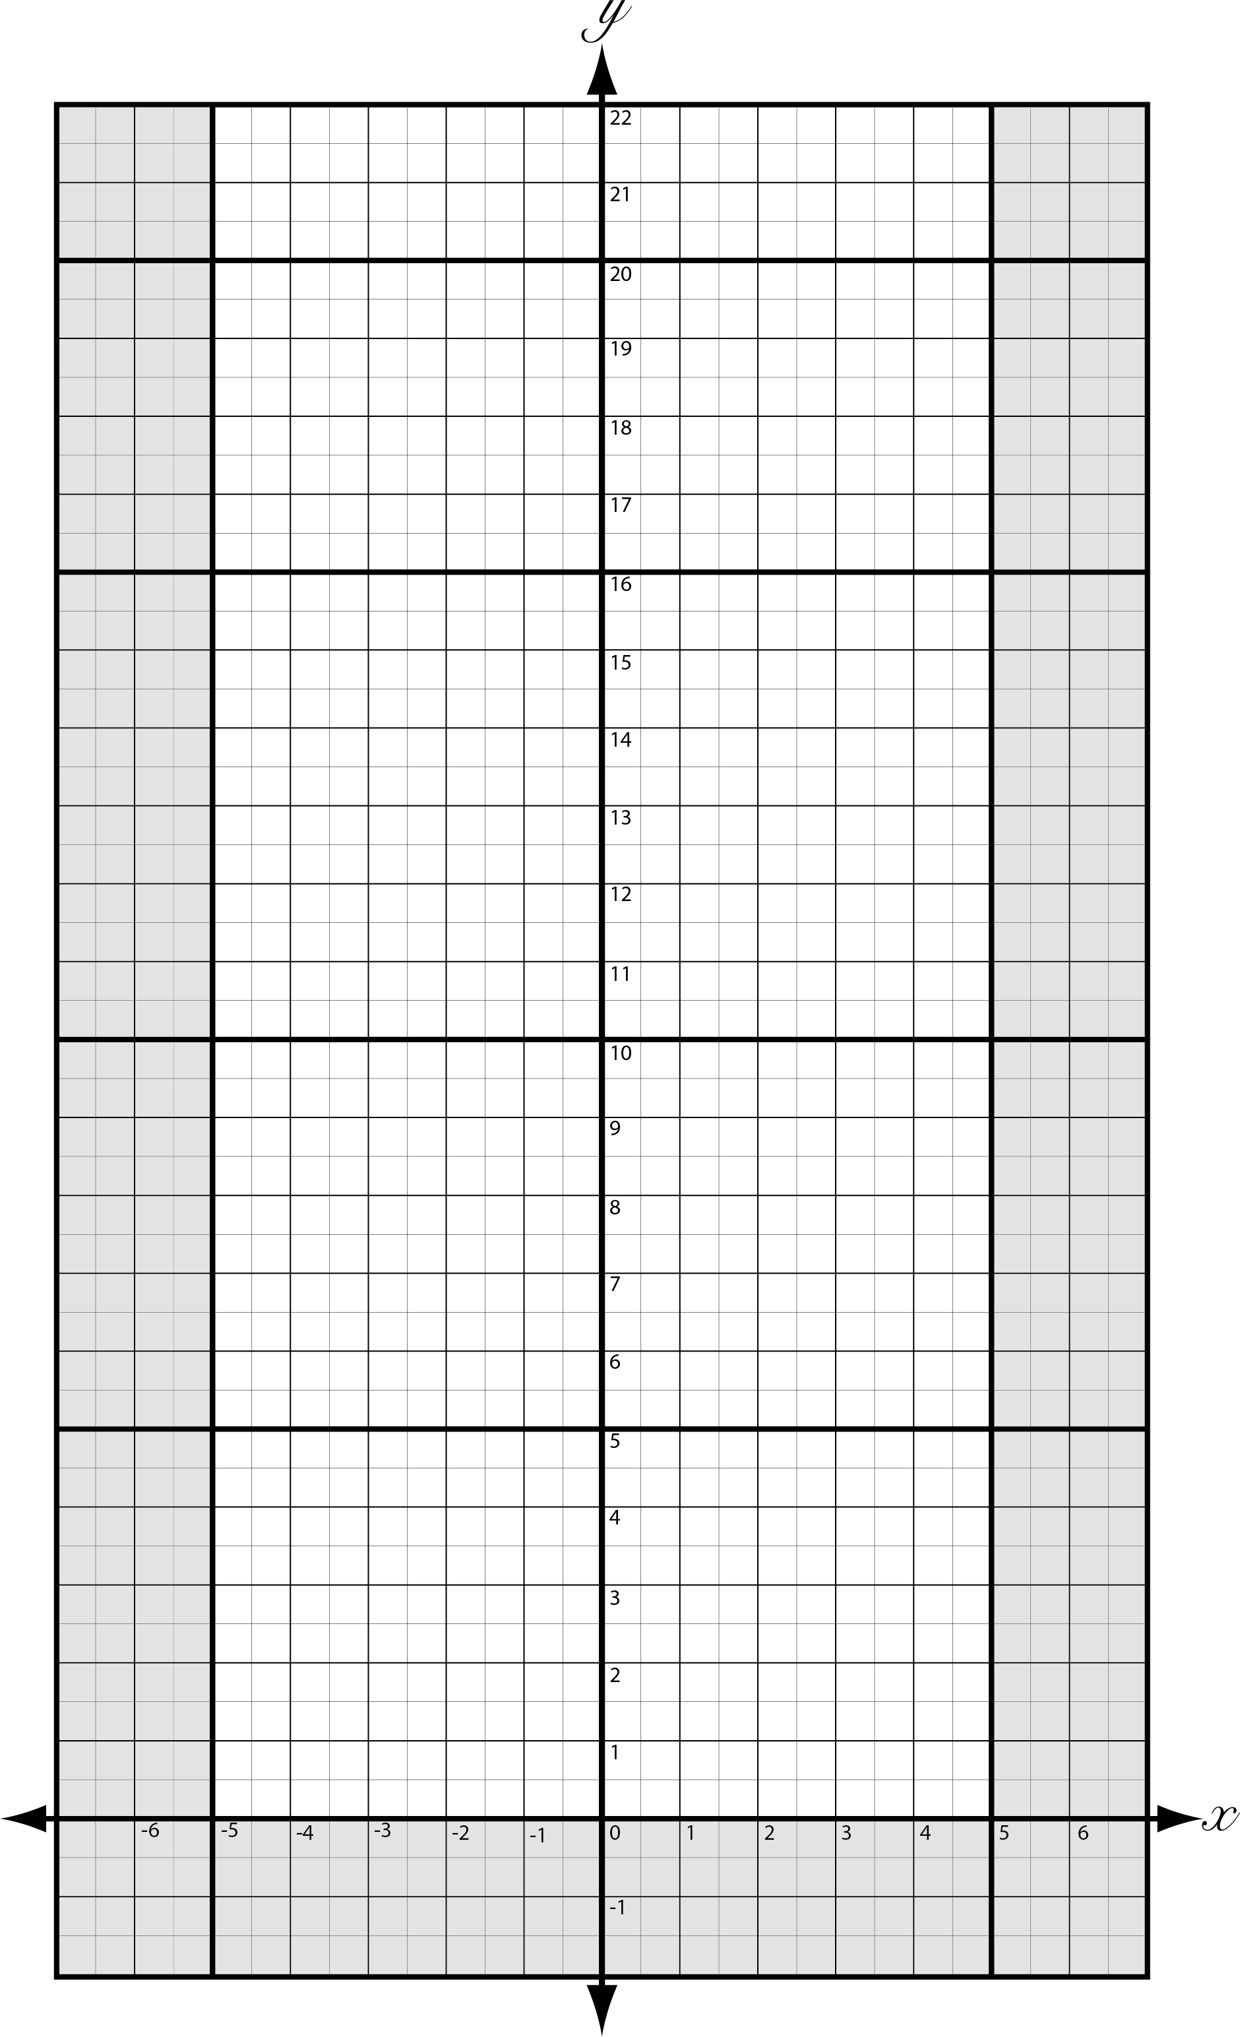

Data Sharing 数据共享
Provide a brief description of how data was collected and shared. Then indicate why collecting this additional data was important.
简要说明如何收集和共享数据，然后说明为什么收集这些额外数据的重要性。

Table 6:
Test Results for the Whole Class

 | Time  时间（s） | Displacement  位移（m） | Deviation  偏差（m） | Distance  距离（m） | Speed  速度（m/s）
Group #1
Group #2
Group #3
Group #4
Group #5
Group #6
Group #7
Group #8
Group #9
Group #10
Group #11
Group #12
Minimum
最小值
Maximum
最大值
Average
平均值

Table 6:
Flight Data & Results for our Entire Class Plotted on a Cartesian Plane

Data Analysis 数据分析

Identify which groups plane was the best for each of the various metrics that have been indicated. Then compare your plane to the plane that you have just identified. Finally, compare your groups plane to the class average (i.e., group __ had the fastest plane. It flew at a speed of __m/s whereas our plane flew __m/s; however, while our plane was not as fast as group __ plane, it was __m/s faster than the class average).
确定出在每种不同的数据类型下哪一组的飞机是最好的。然后将你们组的飞机与其进行比较。最后，将你们组的飞机与班级平均水平进行比较（即，第__组的飞机速度最快。它的飞行速度为__m/s，而我们的飞机飞行速度是__m/s；虽然我们的飞机没有第__组飞机快，但它比班级平均水平快__m/s）。
- Which group had the plane that flew for the longest amount of time?
哪一组的飞机飞行时间间隔最长？
- Which group had the greatest average ‘displacement’ value?
哪一组的飞机平均位移值最大？
- Which group had the smallest average ‘deviation’ value?
哪一组的飞机平均偏差值最小？
- Which group had the plane that flew the greatest ‘distance’?
哪一组的飞机飞行距离最大？
- Which group had the plane that flew the fastest?
哪一组的飞机飞得最快？

Conclusion 结论
Did that data support or disprove your original hypothesis? Be sure to use examples. Provide clear and accurate explanations why each example supports your claim.
这些数据支持或否定了你最初的假设吗？务必举例说明并提供清晰准确的解释。

Recommendations For Future Experiments 对未来实验的建议
Think about the experiment. What could you do differently to improve the quality of this experiment. How would you improve the experiment if you did it over again? What recommendations would you make to future scientist to improve upon this experiment? Are there any questions left unanswered that you would design another experiment for?
回顾整个实验，可以做哪些改变来提高这个实验的质量。如果你重新做一遍将如何改进这个实验？为了改进这个实验，你会向未来的科学家提出什么建议？如果你再设计另一个实验，是否还有些问题没有得到解答？

